**Mid Day Park**

***Work-flow to Use Mid Day Park***

There is currently one Optibus template



Use **Load Template** to set up the preference



Repeat **Load Template** for additional instances of the template



***Preference Overview***

If a break is scheduled during the work day, it may be required to park the vehicle in a designated mid day park location, typically a depot.

***Templates Available from Optibus***

***Mid Day Park***

**Purpose:**

This template allows a mid day park subject to two main conditions: A minimal park time that makes it worthwhile



The park time must fit inside a minimal break length.



The second condition prevents the undesirable situation where a driver finishing his break, cannot take out the vehicle for an additional length of time.

**Prerequisites:** A mid day park location (depot) defined in the user data may be required.

**Opening Dialog:**

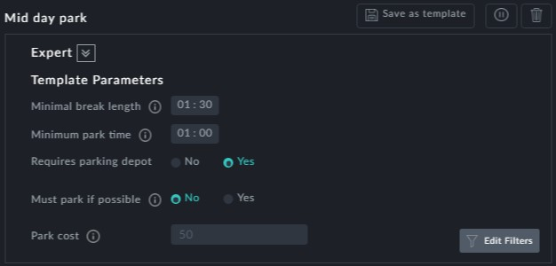

**Points to note:**

In **Template Parameters** -

**Minimal break length**: This is the minimum break length during which a mid day park is allowed. If it is exceeded, the vehicle is always returned to a depot



**Minimum park time**: The minimum park time at a depot excluding Pull in and Pull out time for which a mid day park is justified. To make sense, ensure that it is less than **Minimal break length**.



**Requires parking depot**: Leave this as Yes. A parking depot must have been defined in the user data and this is the default case. Do not set it to No.



**Must park if possible**: This should be set to Yes. Together with the previous item, this enforces mid day parking at a depot when a break exceeds **Minimal break length** and **Minimum park time** can be satisfied.



**Park cost:** Fixed cost for a mid day park

